Intermediate Algebra Lecture 10.3: Simplifying Radical (Roots) Expressions

Product Rule for Radicals
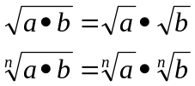

Example
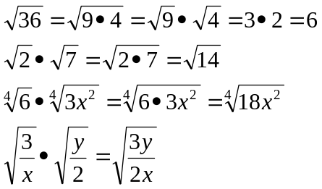

Quotient Rule for Radicals
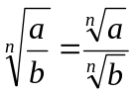

Example
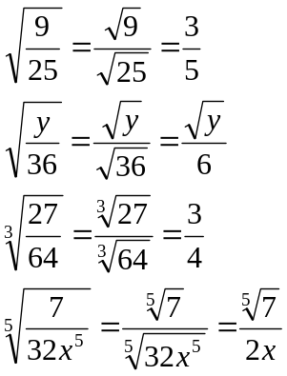

Goal for simplifying Radicals
Find perfect nth numbers

Example
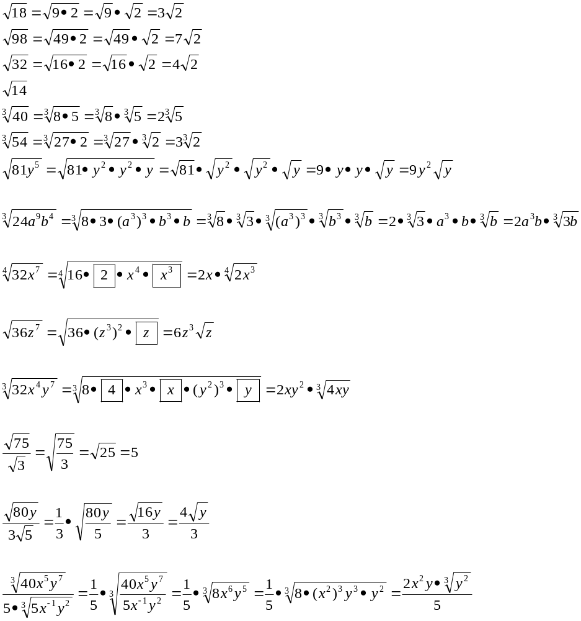

Example
